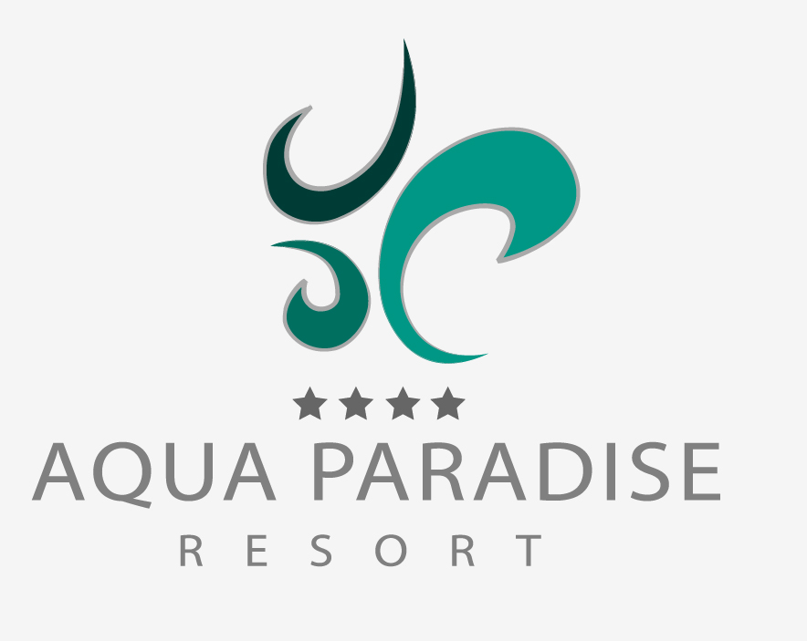

Fact sheet - Summer 2024
GENERAL INFORMATION
OFFICIAL NAME ACCOMMODATION | AQUA PARADISE RESORT
DEPOSIT REQUIRED | YES/NO: NO
GPS COORDINATES * | 42.656285 / 27.684330
ADDRESS | SUNNY BEACH AREA
IN TOWN/CITY/VILLAGE | Ravda, NESSEBAR
PHONE NUMBER | Reception: + 359 55 045 060; +359 879 99 77 99
WEBSITE | WEBSITE: http://aquaparadiseresort.bg/
HOTEL GROUP / HOTEL CHAIN | NO
OFFICIAL CATEGORY (KEYS/STARS) | 4*
UNIQUE SELLING POINTS | ● FREE ENTRANCE TO THE AQUA PARK NEXT TO THE HOTEL COMPLEX
 | ● NEW COMPLEX WITH MODERN AND ECO-FRIENDLY ARCHITECTURE, NATURAL MATERIALS USED.
MOST IMPORTANT TARGET GROUPS | YOUTH: not recommended | COUPLES: YES |  | FAMILIES: YES
YEAR OF CONSTRUCTION | 2017-2018
YEAR/SEASON OF LAST RENOVATION | 2018
RENOVATED AREAS | ALL
TOTAL NUMBER OF BUILDINGS | 3
MAXIMUM NUMBER OF FLOORS | 6
TOTAL NUMBER OF ROOMS | 434
TOTAL NUMBER OF LIFTS | 7
LIFT IN EVERY BUILDING | YES/NO: YES
RECEPTION | YES/NO: YES | 24/7 YES/NO: YES
CHECK-IN FROM: | 15:00H
CHECK-OUT TILL: | 11:00H
LATE CHECK-OUT: | YES/NO: UPON AVAILABILITY | CHARGEABLE/RATE: TBA
COURTESEY ROOM: | YES/NO: NO
LUGGAGE STORAGE ROOM: | YES/NO: YES
PETS ALLOWED | YES/NO: NO | FREE/RATE:
LOBBY | YES
GARDEN | YES
WHEELCHAIR FRIENDLY | YES/NO: YES | SPECIFY LIFTS/ROOMS/FACILITIES: TBA
LOCATION
ACCO AND SEA DIVIDED BY ROAD | YES/NO: YES | SPECIFY:
ACCO AND SEA DIVIDED BY BOULEVARD | YES/NO: YES | SPECIFY:
ON A HILL | YES/NO: NO | SPECIFY:
ON THE SEA (WITHOUT BEACH) | YES/NO: NO | SPECIFY:
ON THE SEA (WITH PUBLIC BEACH) | YES/NO: NO | SPECIFY:
ON THE SEA (WITH PRIVATE BEACH) | YES/NO: NO | SPECIFY:
NEAREST TOWN/CITY | NAME OF TOWN/CITY: RAVDA, NESSEBAR, SUNNY BEACH | METRES/KILOMETRES: 0.5 - 3.0 KM
NEAREST BEACH | NAME OF BEACH: RAVDA | METRES/KILOMETRES: 500M
TYPE OF BEACH (SAND, ROCKS ETC…) | SAND
PUBLIC TRANSPORT IN MTRS/KM | BUS: 1 km | METRES/KILOMETRES:
 | TRAIN: 25 km (Bourgas city) | METRES/KILOMETRES:
 | TAXI: YES | METRES/KILOMETRES:
DISTANCE IN MTRS/KM TO… | TOWN/CITY CENTRE 3.0 km | METRES/KILOMETRES:
 | NEAREST SHOPS 1.0 km | METRES/KILOMETRES:
 | NEAREST RESTAURANTS 1.0 km | METRES/KILOMETRES:
 | NEAREST BARS 1.5km | METRES/KILOMETRES:
TOURIST ATTRACTION : | NAME ATTRACTION: AQUA PARK, NEXT TO THE HOTEL | METRES/KILOMETRES: 50m
SHUTTLESERVICE TO… | Hotel - Ravda – Nessebar - Hotel | FREE/PRICE: 2.5 Euro per person

ROOM FACILITIES
HOTEL ROOM
NAME OF ROOM TYPE | DBL STANDARD/Annex ; DBL SUPERIOR /Hotel
MINIMAL OCCUPATION | 2 pax
MAXIMUM OCCUPATON | 3 pax / 4 pax (in DBL Superior is possible 2 adt + 2 chd or 3 adt + 1 chd)
SIZE IN SQUAREMETRES | 27 -28 sq.m. –> DBL STD ; 32-35 sq.m. DBL SUPERIOR
SEPARATED LIVING ROOM | YES/NO: no
SEPARATED BEDROOM | YES/NO: no
TELEPHONE | YES/NO: yes
AIRCONDITIONING | YES/NO: yes | FREE/PRICE: FREE
TELEVISION | YES/NO: yes | SATELLITE/CABLE:
MINIBAR | YES/NO: YES (on request) | FREE/PRICE: as per price list in the room
REFRIDGERATOR | YES/NO: mini fridge – YES | FREE/PRICE: free
SAFE | YES/NO: yes | FREE/PRICE: free
COFFEE- & TEA FACILITIES | YES/NO: YES, UPON REQUEST DUE TO COVID – 19 MEASURES | FREE/PRICE: FREE
WIFI IN ROOM/APPARTMENT | YES/NO: yes | FREE/PRICE: free
BATH TUB | YES/NO: YES (in very limited number of rooms)
SHOWER | YES/NO: yes | WALK-IN SHOWER: YES/NO – yes
BATH TUB WITH SHOWER | YES/NO: no
HAIR DRYER | YES/NO: yes
BATHROBE | YES/NO: no
SLIPPERS | YES/NO: no
BALCONY OR TERRACE | YES/NO: yes
CHAIRS ON BALCONY OR TERRACE | YES/NO: yes
VIEW | TYPE: Random | FREE/PRICE: No
REMARKS | All facilities in Std and Superior rooms are the same, the difference is only the size. There are also smaller rooms – SGL room, king-size bed 160cm/190 cm –22 sq.m.

FAMILY ROOMS
NAME of ROOM TYPE | Family room in the contracts (Family Annex & Family Hotel)
MINIMAL OCCUPATION | As per contract: depends on the contract
MAXIMUM OCCUPATON | As per contract: depends on the contract
SIZE IN SQUAREMETRES | 56-62 m²
SEPARATED LIVING ROOM | YES/NO: see below
SEPARATED BEDROOM | YES/NO: Each Family room consists of 2 bedrooms and 1 living room.  Family room Hotel – The kid’s room is separated by door, the parent’s room is with open space to the living room.  Family rooms in Annex buildings are with fully separated living room and bedrooms.
KITCHENETTE | YES/NO: no
OVEN | YES/NO: no
MICROWAVE | YES/NO: no
STOVE / COOKING PLATES | YES/NO: no | HOW MANY?
TOASTER | YES/NO: no
DISHWASHER | YES/NO: no
WASHING MACHINE | YES/NO: no
TELEPHONE | YES/NO: yes
AIRCONDITIONING | YES/NO: yes | FREE/PRICE: FREE
TELEVISION | YES/NO: yes | SATELLITE/CABLE: CABLE
MINIBAR | YES/NO: Yes (on request) | FREE/PRICE: as per price list in the room
REFRIDGERATOR | YES/NO: yes (mini fridge) | FREE/PRICE: free
SAFE | YES/NO: yes | FREE/PRICE: free
COFFEE- & TEA FACILITIES | YES/NO: yes, UPON REQUEST | FREE/PRICE: FREE
WIFI IN ROOM/APPARTMENT | YES/NO: yes | FREE/PRICE: free
BATH TUB | YES/NO: yes, but in very limited number and only in Fam. rooms HOTEL
SHOWER | YES/NO: yes | WALK-IN SHOWER: YES/NO - yes
BATH TUB WITH SHOWER | YES/NO: no
HAIR DRYER | YES/NO: yes
BATHROBE | YES/NO: no
SLIPPERS | YES/NO: no
BALCONY OR TERRACE | YES/NO: yes
CHAIRS ON BALCONY OR TERRACE | YES/NO: yes
VIEW | TYPE: run of the hotel Random | FREE/PRICE: No
REMARKS | All Family rooms are with 2 separated bathrooms  There are also 1 bedroom APT furnished as the Family rooms, but with 1 separated bedroom, 1 bathroom and additional WC. Size of the unit:50-52 m2

FOOD & BEVERAGE FACILITIES
RESTAURANTS | NAME OF RESTAURANT | BUFFET OR À LA CARTE | TYPE OF DISHES / THEMES | INCLUDED IN CONCEPT
RESTAURANT #1: | MAIN | Buffet | International, theme nights 7 times per week | yes
RESTAURANT #2: | Adria Restaurant | Buffet | Italian | According to the number of minimum overnights stated in the AI concept. (pre-booking on spot required)
RESTAURANT #3: | Baltic Restaurant | À-LA-CARTE | Fusion | According to the number of minimum overnights stated in the AI concept. (pre-booking on spot required)
REMARKS

ALLERGY/DIET OPTIONS
YES/NO: yes | WHICH KIND: gluten free, vegan food, vegetarian food – to be requested in advance

BARS | NAME OF BAR | SELF SERVICE YES/NO | THEME/SNACKS/POOL | INCLUDED IN CONCEPT
BAR #1: | Snack/pool bar Adria | Yes |  | Yes
BAR #2: | Snack/Pool bar Baltic | Yes |  | Yes
BAR #3: | Lobby bar | No |  | Yes
BAR #4: | Café-bar | No |  | Yes
BAR #5: | Bowling bar | No |  | Yes
BAR #6: | Animation bar | No |  | Yes
REMARKS | At the lobby bar and the Bowling bar is possible to offer drinks with imported alcohol which are subject of extra charge

DISCO | YES/NO: no | INCLUDED IN CONCEPT YES/NO:
REMARKS
ROOM SERVICE | YES/NO: YES | INCLUDED IN CONCEPT YES/NO: No
REMARKS
CONCEPT
BASIC TYPES OF STAY | YES/NO: | BUFFET OR À LA CARTE
LODGEMENT (ROOM ONLY)
BED & BREAKFAST
HALF BOARD
FULL BOARD
REMARKS | All-inclusive

ALL INCLUSIVE CONCEPT | TIMES | BUFFET, À LA CARTE, SELF SERVICE
BREAKFAST
LATE BREAKFAST
LUNCH | SEE the ALL INCLUSIVE CONCEPT listed in separate document
DINNER
SNACKS
COFFEE, TEA & COOKIES
ICE CREAM
MIDNIGHT SOUP / SNACK
LOCAL SOFT- & ALCOHOLIC DRINKS
IMPORT DRINKS | ARE NOT INCLUSIVE
NOT INCLUSIVE
REMARKS

ULTRA ALL INCLUSIVE CONCEPT | TIMES | BUFFET, À LA CARTE, SELF SERVICE
BREAKFAST | NA
LATE BREAKFAST
LUNCH
DINNER
SNACKS
COFFEE, TEA & COOKIES
ICE CREAM
MIDNIGHT SOUP / SNACK
LOCAL SOFT- & ALCOHOLIC DRINKS
IMPORT DRINKS
NOT INCLUSIVE
REMARKS

SWIMMING POOL FACILITIES
POOLS | FRESH OR SEA WATER | HEATED |  | SLIDES |  | THEME
POOL #1: | Fresh | Y/N | PERIOD: NO | Y/N | HOW MANY: 0 | Outdoor / Active area
POOL #2: | Fresh | Y/N | PERIOD: NO | Y/N | HOW MANY: 0 | Outdoor / Relax area
POOL #3: | Fresh | Y/N | PERIOD: NO | Y/N | HOW MANY: 0 | Outdoor / Relax area
POOL #4: | Fresh | Y/N | PERIOD: YES, (MAY; SEP & OCT) | Y/N | HOW MANY: 0 | Indoor
POOL #5: |  | Y/N | PERIOD: | Y/N | HOW MANY:
POOL #6: |  | Y/N | PERIOD: | Y/N | HOW MANY:
POOL #7: |  | Y/N | PERIOD: | Y/N | HOW MANY:
POOL #8: |  | Y/N | PERIOD: | Y/N | HOW MANY:
REMARKS

CHILDREN POOLS | FRESH OR SEA WATER | HEATED |  |  | SLIDES |  | THEME
POOL #1: | Fresh | Y/N |  | PERIOD: NO | Y/N | HOW MANY: 0 | Outdoor / Active area
POOL #2: | Fresh | Y/N |  | PERIOD: NO | Y/N | HOW MANY: 0 | Outdoor / Relax area kids section
POOL #3: | Fresh | Y/N |  | PERIOD: YES (MAY; SEP & OCT) | Y/N | HOW MANY: 0 | Indoor / section
POOL #4: |  | Y/N |  | PERIOD: | Y/N | HOW MANY:
POOL #5: |  | Y/N |  | PERIOD: | Y/N | HOW MANY:
POOL #6: |  | Y/N |  | PERIOD: | Y/N | HOW MANY:
POOL #7: |  | Y/N |  | PERIOD: | Y/N | HOW MANY:
POOL #8: |  | Y/N |  | PERIOD: | Y/N | HOW MANY:
REMARKS
LOUNGERS | YES/NO: YES |  | FREE/PRICE: free
MATRASSES | YES/NO: NO |  | FREE/PRICE: n/a
SUNSHADES | YES/NO: YES |  | FREE/PRICE: free
TOWELSERVICE | YES/NO: YES |  | FREE/PRICE/DEPOSIT: FREE/ Pool Towel Card service
REMARKS

BEACH FACILITIES
PRIVATE BEACH | YES/NO: NO
LOUNGERS | YES/NO: NO | FREE/PRICE:
MATRASSES | YES/NO: NO | FREE/PRICE:
SUNSHADES | YES/NO: NO | FREE/PRICE:
REMARKS | There is a public beach where local managements companies offer sun beds and sun-umbrellas for extra charge

INTERNET FACILITIES
WIFI PUBLIC AREAS | YES/NO: YES | FREE/PRICE: FREE | SPECIFY AREAS: lobby area, reception
INTERNETCAFE | YES/NO: YES NO | FREE/PRICE: TBA
REMARKS

KIDS FACILITIES
CLUB & ENTERTAINMENT | AGES | NUMBER OF DAYS A WEEK | AVAILABLE DURING WHOLE SEASON? | LANGUAGES
MINICLUB | 4-12 | 6 | YES/NO: YES | ENG, BUL, CZ
MIDICLUB |  |  | YES/NO: NO
TEENAGE CLUBS |  |  | YES/NO: NO
KIDS ENTERTAINMENT |  |  | YES/NO: YES - game zone, extra charge
REMARKS

MINIDISCO | YES/NO: YES
PLAYGROUND | YES/NO: YES
LUNA PARK | YES/NO: NO | FREE/PRICE:
BABY COTS | REQUEST AT BOOKING REQUIRED: YES | FREE/PRICE: FREE
BABYSIT SERVICE | REQUEST AT BOOKING REQUIRED: NO | FREE/PRICE: N/A
REMARKS

SPORT, RECREATION & RELAXATION FACILITIES
SPORT | YES/NO: | FREE/PRICE:
AEROBICS | NO
YOGA | NO
ARCHERY | NO
BASKETBALL | YES | FREE
VOLLEYBALL | YES | FREE
BEACH VOLLEYBALL | NO
BOCCIA / PETANQUE / JEU DE BOULES | NO
DARTS | YES | Extra charge
FOOTBALL | YES (mini football) | Free
TABLE FOOTBALL | YES | Charge – price TBA
BILLIARDS | YES | Charge – price TBA
TABLE TENNIS | YES | Charge – price TBA
TENNIS | YES | Charge – price TBA
SQUASH | NO
MINI GOLF | NO
BOWLING | YES | Charge – price TBA
GAME ROOM | YES | Charge – price TBA
DIVING CENTRE | NO
WATERSPORTS | At the public beach | Charge – price TBA
REMARKS & OTHER FACILITIES + COSTS

RELAXATION | YES/NO: | FREE/PRICE:
FITNESS / GYM | YES | FREE
HAMAM | YES | Charge – price TBA
SAUNA | YES | FREE
INDOOR POOL | YES | FREE
JACUZZI | YES | FREE
MASSAGES | YES | Charge – price TBA
BEAUTY TREATMENTS | NO
HAIRDRESSER | NO
REMARKS & OTHER FACILITIES + COSTS

ENTERTAINMENT | YES/NO: | NUMBER OF DAYS A WEEK
FOR ADULTS | Evening show programs from the animation team | 7
SHOWS | Evening show programs from the animation team | As per the program of the animation team listed in the hotel
LIVE MUSIC
REMARKS & OTHER FACILITIES + COSTS
OTHER FACILITIES
SHOPS | YES/NO: YES | NUMBER OF SHOPS: TBA
MINI MARKET | YES/NO: YES, charge
LAUNDRY & DRY SERVICE | YES/NO: YES, charge
MEDICAL SERVICE | YES/NO: YES, charge
PRIVATE PARKING | YES/NO: YES | FREE/PRICE: free
PUBLIC PARKING | YES/NO: NO | FREE/PRICE:
REMARKS / OTHER FACILITIES + COSTS

