

Imagine endless golden beaches, sea waves that almost reach your terrace, a beautiful park where you can have rest from the sun in the afternoon, imagine a cozy room with modern furniture, that embraces you with soft linens and discreet aroma so you can enjoy maximum relaxation, imagine elegant restaurants ready to meet and exceed your expectations, imagine magical places for your kids, where

they can play and have fun…
Now open your eyes and enjoy the experience: Reina Del Mar!

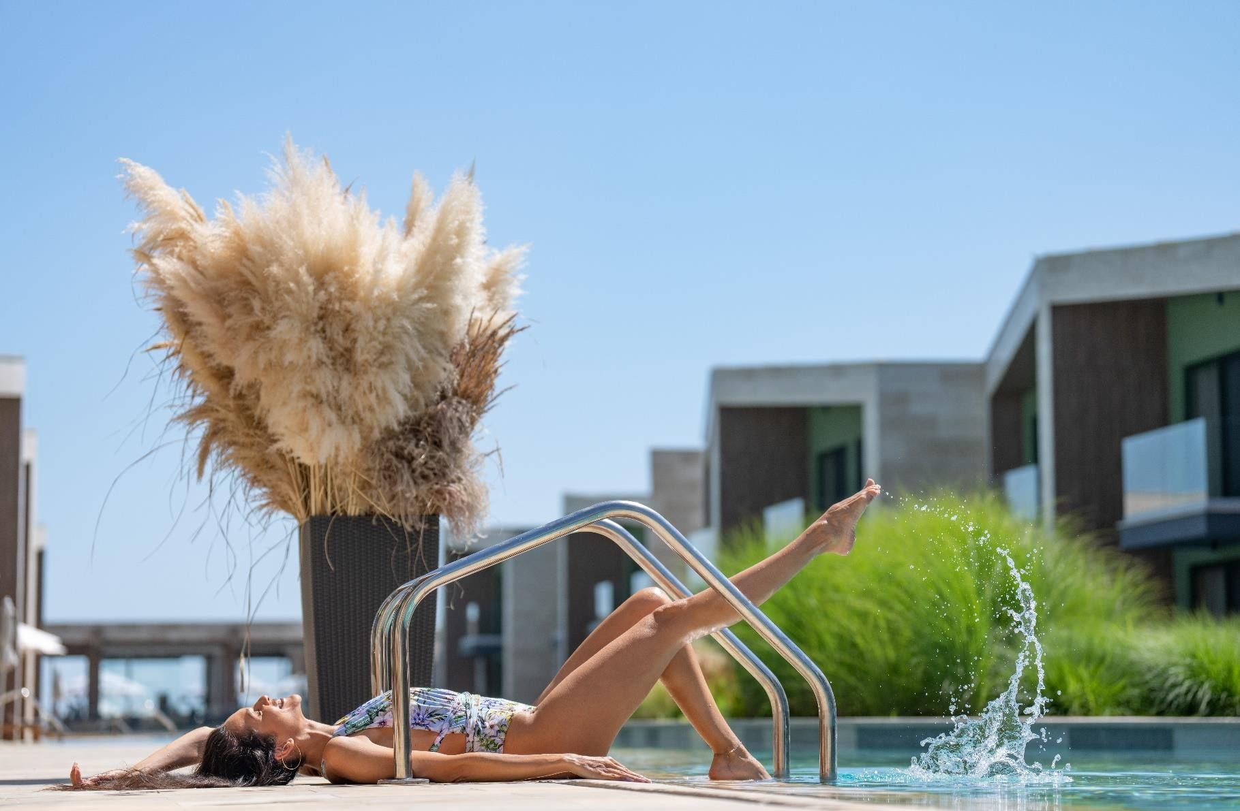
Reception | + 359 884 407 402

www.reinadelmar-bg.com
Obzor 8250, Bulgaria, 1 Chernomorska Str.

- Breakfast in Main buffet Restaurant 07:30-10:00

Ultra All Inclusive 2024
- Breakfast in Second buffet Restaurant (July-August) 08:00-10:30
- À la carte Breakfast in Restaurant “Amalia” 08:00-11:00
- Late riser Breakfast at the Snack Bar 10:00-12:00

:
- Lunch in Main buffet Restaurant 12:30-14:00
- À la carte Lunch in Restaurant “Amalia” 12:00-15:00
- À la carte Lunch in the Beach Club 12:00-16:30
- Lunch in the Snack bar 12:00-16:30
- Afternoon Snack at the Snack bar 12:15-15:00

- Dinner in Main buffet Restaurant 18:00-21:00
- À la carte Dinner in Restaurant “Amalia” (Italian) 19:00-21:30
- À la carte Dinner at the Snack bar (Turkish) 19:00-21:30
- À la carte Dinner in the Beach Club (Mediterranean) 19:00-21:30
- À la carte Dinner in Second buffet (Indian) 19:00-21:30
- Midnight Snack in Lobby bar 22:00-07:00

- Gala dinner - once per week

You can enjoy our Special Theme evenings in the main buffet Restaurant –Asian, Mediterranean, Italian, Balkan, Turkish
- Baby buffet in the main buffet and second buffet Restaurant – baby puree, Danonino, baby Biscuits, Fruit pouch, Pudding, Baby water, Infant Formula powder

À la carte dinner in each restaurant is available once per stay for minimum 5 nights stay (upon availability; reservation is required).
- Snack bar, Beach Club, Amphitheater bar are open from June until the beginning of September. Second buffet restaurant is open only in July and August.

Hotel reserves the right to change the type of restaurants and their opening hours due to low
occupancy and weather forecast

Ultra All Inclusive concept includes bottled local and IMPORTED beverages (alcoholic and non-alcoholic drinks)
Ultra All Inclusive 2024

Refreshing cocktails and drinks you can enjoy at each of our bars:
  - Lobby Bar and Patisserie 00:00-24:00

Lounge Bar with open terrace and panorama view 17:00-01:00
(Adults only; selected beverages at additional cost)
  - Pool Bar (June, July, August) 09:00-24:00
  - Pool Bar (May, September) 09:00-18:00

Amphitheater Bar / Coffee shop Café Vergnano 10:00-23:00
  - Café & Patisserie 09:00-17:00

Vitamin Bar in SPA 09:30-19:30

Beach and Pool services
  - Free sunbeds, umbrellas and towels at the beach (upon availability)
  - Drinks service at the beach and by the pool
  - Free sunbeds, umbrellas and towels by the pool (upon availability)
  - Relax pool for adults (outdoor & heated)
  - 2 Outdoor swimming pools for adults
  - Baby and kids pool with waterslides (outdoor & heated)
  - Indoor pool for adults and children (heated)

Rooms are equipped with:
  - Coffee machine with capsules and tea set - daily refilled, free of charge
  - Mini bar in the room - daily refilled free of charge with mineral water, soft drink
/Coca Cola, Sprite/, soft drinks for children “Cappy”, White and Red Wine 0.187ml, Beer, Chocolate dessert, Roasted nuts, Chips, jelly candy
  - Safe (free of charge)

Luxury bath accessories and cosmetics, bathrobes and slippers

For Kids:
  - Baby club /6m – 36m/ - free of charge, babies have to be accompanied by parents
  - Babysitting – with extra charge (July and August)
  - Mini club /4 y.o. – 12 y.o./
  - Daily children's animation for kids group 8-12 years and teen group 13-17 years (July and August)
  - Kids show for children over 4 y.o. (July and August)
  - Mini disco

  - Baby and children’s pool (outdoor & heated)

Ultra All Inclusive 2024
  - Kid’s playground
  - Baby cot (on request, free of charge)
  - Baby TV Channel
  - High chairs
  - Baby toolkit (baby potty, baby bath tub, baby changing, baby cosmetics, kid`s robes) - on request, free of charge
  - Baby stroller – on request, free of charge
  - Baby buffet in the main restaurant - baby puree, Danonino, baby Biscuits, Fruit pouch, Pudding, Baby water, Infant Formula

Animation for adults:
  - Beach volleyball, football, water polo, table tennis, bocce, darts
  - Stretching, body fit, dance fit, water gymnastics
  - Dance and variety program, live music, beach party (July and August/)

Reina SPA & Wellness area
With free access
  - Indoor heated swimming pool, Relaxing pool with underwater jets, Children’s pool, Herbal steam bath, Finnish sauna, Soft sauna, Room with natural Himalayan salt, Snow room, Relaxation area
  - Professional fitness studio

With extra charge
  - Massages
  - Face and body procedures
  - Zero body; SPA Suite; Hammam

Additional free services:
  - Free Wi-Fi access throughout the hotel

Free parking – 24 hours guarded

It is good to know:
  - Check-in is after 15:00
  - Check-out is till 11:00
  - Smoking is not allowed in all open and closed areas of the restaurants;
  - Wearing a bracelet is required in order to use all Ultra All Inclusive services
  - Ultra All-Inclusive package starts with lunch and finish with breakfast on the day of departure.
  - The Ultra All-Inclusive service is for use only in the complex. Taking food, drinks and mini-bar out of the complex is unacceptable!

