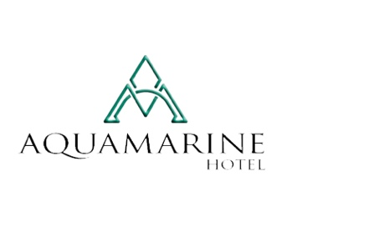
Buffet meals at the Main Restaurant:

Breakfast - 08:00h. - 10:00h.
/Variety of sausages, dairy products, fruit andvegetables, pasta, omelettes, desserts, juice, table water and hot drinks/

Lunch - 12:00h. - 14:00h.
/ Traditional main courses, salads, soups, fruit, desserts, soft drinks, water, draft beer,draft wine/

High Tea– 16:00h. – 17:00h.
/cookies, pretzels, fruit, ice cream/

Dinner – 19.00h. - 21:00h.
/Main courses, salads, dressings, fruit, desserts, Bulgarian alcohol, soft drinks, water/

Free drinks:
*Soft drinks (juice, Coca-Cola, Fanta, Sprite, tonic, soda, mineral water), hot beverages (coffee, tea, milk, chocolate milk), draft wine and beer are included throughout the day from 08:00 to21:00.
*Bulgarian alcoholic drinks (vodka, brandy, rum, mint, gin, whiskey, draft wine) are includedfrom 10:00 to 21:00.

- Free use of the outdoor pool;
- Free sun loungers, cushions and umbrellas by the pool; or on the beach area(until quantities are exhausted)

- Free fitness;
- FreeWi-Fi;
- Free parking;
- Safe in the room;
- Relax zone
- Jacuzzi

For children:
- Outdoor playground;
- Children's section in the outdoor pool;
- Children's chairs in the restaurant;
- Baby cots (provided free of charge);

Additional services against payment:

- All imported alcoholic drinks are to be paid for;
- Phone calls;
- Towels for the swimming pool and beach - for 10EUR deposit per towel at reception. In case of damage, the deposit is not returned;
- Laundry and dry cleaning;
- The mini bar can be stocked at the guest’s request upon arrival;
- Taxis, car rentals, medical services;
- A la carte restaurant "DEL MAR" offering Mediterranean cuisine - located on the beach in the front of the hotel;
- A la carte restaurant "Izvora" offering guests traditional Bulgarian cuisine, barbecue and live music (reservation required);

Notes:

- Check-in after 15:00h.
- Check-out the day of departure - to 12:00h. Late check-out upon availability – extra payment.
- The right to use the All Inclusive programs closely associated with the hotel and requires wearing a bracelet.
- The All Inclusive program begins with the high tea upon arrival and ends with the lunch on the day of departure.
- All hotel towels left unattended on pool sun loungers will be collected by staff without warning.
- Please note that the towels are replaced only if the dirty ones are in the room. If they are not, the cleaning staff are instructed not to bring any clean towels.
- Should you decide to leave earlier than planned, please note that the AMOUNT PAID IS NOT RETURNED!

