VERDE HOTEL İÇMELER 16 +
2023 SUMMER FACT SHEET & CONCEPT

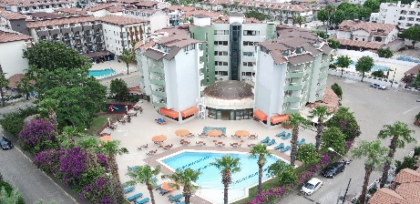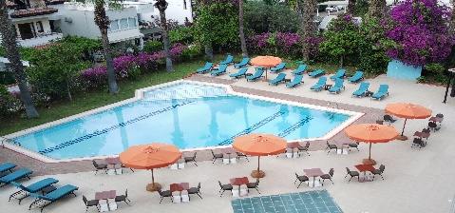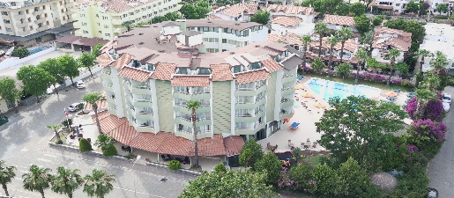

GENERAL INFORMATION

Name of Hotel : VERDE HOTEL
Official Category : 4 Stars
Adresse : İçmeler Mahallesi , Sahil Sokak , No : 23 Marmaris / Muğla
Telephone : 0090 252 455 26 00
Web Site : www.verdehotelicmeler.com
E-mail : info@verdehotelim.com reservation@verdehotelim.com
Board Type : All Inclusive
Languages : Turkish , English , Russian
Season : 01.05.2023 - 31.10.2023

LOCATION

Location : İçmeler , Center
Distance to Airport : Dalaman Airport 100 km , Bodrum Airport 130 km
Distance to City Center : 9 km
Distance to Public Beach : 200 m (Sandy and Pebble)
Distance to Bar Street : 10km
Distance to Water Parks : 7 km
Distance to State Hospital : 9km
Distance to Ahu Hospital : 8 km
Distance to Yucelen Hospital : 15 km

HOTEL INFO

Hotel Building : 1 Block With 6 Floors
Elevator : 2 ( 1 Guest , 1 Service )
Built : 1991
Renovation : 2023
Total Area : 3.025 m2
Total Number of Rooms : 102
Total Number of Beds : 204

OTHER

Credit Card : Visa – Master
Pets : Not Allowed
Voltage : 220 V
Handicapped Suitable : 1 Room
Non Smoking area : Smoking Is Not Permitted In Indoors
Wi-Fi : Free , ( Rooms , General Areas , Pool Side )

OTHER SERVICES AND FACILITIES

Sauna –Fitness – Turkish Bath – Steam Room : Free (With Reservation, Upon Availability)
Massage and SPA style Turkish Bath treatments : Extra Charge
Transfers : Extra Charge
Doctor : Extra Charge (Is Call On Request)
Dart Games : Free
Playing Cards ,Tavla, : Free
Mini Billiard : Free
TV Lounge : Lobby , Restaurant , Bar
Beach Towel : With Deposite Fee ( 5 GBP)

RECEPTION

Reception : 24 hours
Car Parking : Free( Subject To Availability,Along To Road )
Check in : 14:00
Check out : 12:00
Exchange Service : √
Luggage Room : √
Wake up Service : √
Bellboy and porter Service : √
Concierge Service : √
Phone Calls : Extra Charge
Taxi Minibus
: Extra Charge
SWIMMING POOL

Swimming Pool : 220 m2 -228 m3 Fresh Water
Swimming Pool Depth : 1.25 cm – 1.45 cm Max
Pool Hours : 08:00 - 18:30
WC : √
Showers : √
Sunbeds and parasols : Free (Upon Availability)
Locker Cabin : √

FOOD & BEVERAGE

Breakfast : 07:30 – 09:30 ( Open Buffet )
Late Breakfast : 09:30 – 10:00 ( Fix Buffet)
Lunch : 12:30 – 14:00 ( Open Buffet )
Snack : 14:00 – 16:00 ( Set Menu )
Coffee Break : 17:00 – 17:30 ( Fix Buffet )
Dinner : 19:30 – 21:30 ( Open Buffet )
Pool Bar : 10:00 – 23:00 ( Local Alcoholic and Non Alcoholic,Cold And Hot Drinks)
Hot Drinks Corner : 07:30 – 23: 00 ( Tea , Coffe , Juices)
Honeymoon Setup : Wine and Fruit Basket
Extras : Turkish Coffe, Imported Drinks , Cocktails, Bottled and Canned Drinks,
Fresh Fruit Juices , Bottled and Quality wines )
Extra Bar : Extra Charged
SPA Vitamin Bar : Extra Charged
Capacity of Indoor Restaurant : 80 Pax
Capacity of Outdoor Restaurant : 120 Pax

ACCOMODATION
Room Type RrpRRRRRRRRRRRRRRRRRRRRRRSTANDART ROOM
Units 102
Total Beds 204
Max Pax 3
Room Vıew Street -Pool -Mountain
Size 25 m2
Floor Ceramic Tiles
Split A/C √
Lcd TV √
Balcony √
Direct Phone √
Minibar Daily 2 Bottles Of Water (Free )
Kettle setup Free
Energy Saver √
Electronic lock system √
Desk and Mirror √
Hair Dryer √
Telephone in Bathroom √
Toiletries √
Walkin-shower √
Room Cleaning Daily
Linen Change Every 3 Days
SAT TV Chanells English - Turkish - Russian
Wardrobe √
Luggage Rack √
Side Table and Chairs √
Safe Box With Deposite fee (10 GBP)
Fire Alarm System √

GENERAL INFORMATION AND RULES

- VERDE HOTEL SERVES OVER AGE OF 16
- CHECK IN TIME IS 14:00 , CHECK OUT TIME IS 12:00
- ALL INCLUSIVE CONCEPT BEGINS AT 14:00 ON ARRIVAL DAY AND CONTINOUS TILL 12.00 ON DEPARTURE DAY.
- FOR YOUR SAFETY , IT IS MANDATORY TO WEAR YOUR WRIST BAND DURING YOUR STAY.
- HOTEL MANAGEMENTS HOLDS THE RIGHT TO CHANGE THE TIME AND LOCATION OF THE OPERATIONS.
- ALL THE SERVICES AND ACTIVITIES ARE SUBJECT TO WEATHER CONDITIONS , WHEN THE CONDITIONS ARE NOT AVAILABLE IT IS NOT POSSIBLE TO GIVE SOME OF THE SERVICES.
- PETS ARE NOT ALLOWED.
- OUR GUESTS CAN WELCOME THEIR VISITORS OUTSIDE ENTRANCE OF THE HOTEL BY INFORMING THE RECEPTION.
- SPECIAL REQUESTS ARE SUBJECT TO AVAILIBILTY UPON CHECK-IN AND MAY INCUR ADDITIONAL CHARGES . SPECIAL REQUESTS CAN NOT BE GUARANTEED.
- YOU CAN RENT A SAFETY DEPOSITE BOX IN YOUR ROOM (WITH DEPOSITE FEE) OTHERWISE THE HOTEL CAN NOT BE HELD RESPONSIBLE FOR LOSS OF YOUR VALUABLE ITEMS.
- IN CASE LOST OF YOUR SAFE-BOX KEY , WILL BE CHARGED 10.- GBP
- ONLY ONE ROOM KEY CARD IS GIVEN DUE TO THE SOFTWARE.OUR GUESTS ARE REQUIRED TO RETURN THE ROOM KEY CARD WHEN CHECKING OUT. IN CASE LOST OF ROOM KEY CARD WILL BE CHARGED 10.- GBP.
- PLEASE BE CONSIDERATE OF OTHER GUESTS AND KEEP ON WITH NO SWIMSUITS AND WET CLOTHING IN THE LOBBY AND THE RESTAURANTS.
- PLEASE DONT SMOKE IN YOUR ROOMS AND INDOORS.PLEASE USE THE BALCONY FOR SMOKİNG.PLEASE USE ASHTRAY, DO NOT THROW CIGARETTES OUT OF THE BALCONY.
- PLEASE KINDLY READ THE HOTEL FIRE GUIDE.
- ALCOHOLIC BEVERAGES ARE NOT SERVED TO PERSONS UNDER 18 YEARS OF AGE.
- POLICARBON OR PLASTIC GLASSES ARE USED AROUND THE POOL.
- OUR ALL INCLUSIVE CONCEPT IS SELF SERVICE.
- PLEASE DO NOT TAKE ANY KIND OF FOOD AND BEVERAGES AND RESTAURANT MATERIALS OUT OF THE RESTAURANTS AND YOUR ROOMS.
- VEGETERIAN AND DIET MENUS ARE PREPARED ACCORDING TO REQUESTS OF OUR GUESTS.
- BRAND , TYPES AND PRESENTATION PREFERENCES OF ALL ALCOHOLIC AND NON ALCOHOLIC BEVERAGES ARE DETERMINED BY THE HOTEL.
- SUN LOUNGERS AND PARASOLS ARE FREE IN OUR OWN BEACH AND POOL. (UPON AVAILIBILITY).
- IN PUBLIC BEACH , ENTRANCE ARE FREE , SUN LOUNGER , MATTRESS AND PARASOLS ARE CHARGED .
- PLEASE KINDLY READ AND FOLLOW POOL RULES.
- PLEASE FOLLOW THE POOL RULES, OTHERWISE THE HOTEL CAN NOT BE HELD RESPONSIBLE FOR THE ACCIDENTS THAT MAY OCCUR.
- IT IS PROHIBITED BY HYGIENE REGULATIONS TO ENTER THE POOL WITH ANY CLOTHING OTHER THAN SWIMMING CLOTHES.
- PLEASE DO NOT CARRY YOUR BATHROOM TOWELS TO THE POOL AND BEACH.
- ACCOMODATION AT THE FACILITY BEGİNS WİTH LUNCH ON ARRIVAL DAY AND ENDS WITH BREAKFAST ON THE DEPARTURE DAY.
- OUR GUESTS WHO HAVE FINISHED THEIR STAY ARE SUBJECT TO A FEE TO BENEFIT FROM THE ALL INCLUSIVE SYSTEM AND THEY CAN GET NECESSARY INFORMATION FROM THE RECEPTION.
- A LATE CHECK-OUT İS UPON AVAILIBILTY OF THE HOTEL WITH CHARGE.

WE WISH YOU HAPPY HOLIDAYS

VERDE FAMILY

