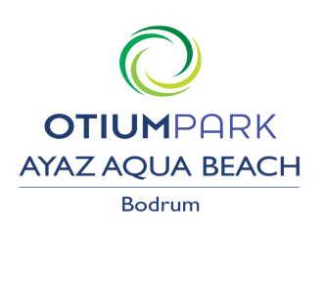

ALL INCLUSIVE PACKAGE
Breakfast : 07:00 – 10:00 open buffet
Lunch : 12:30 – 14:30 open buffet
Dinner : 19:00 – 21:00 open buffet
Snack : 11:00-17:00
Restaurant bar : 12:30 – 14:30 / 19:00 – 21:00
Pool bar : 09:00 – 23:00
Coconout bar : 10:00 – 23:00 (EXTRA)
Coco bar (beach) : 10:00-18.00
İnternet wireless : (free) user name : passport number
pasword : room number

If you want to have a lunch box please order the reception untıl 6 o’clock pm
AVAILABLE EXTRAS (PAYABLE LOCALY)
safe box : free in the room
Beach Towels : Deposit (5 EURO / 5 USD)
Pier Entrance :10EURO (Per Person)
imported drinks,bottle of wine,bottle of water
after 23:00 O’clock all drinks
ROOM İNFO: Make sure the balcony door is closed before turning on the Air CO. Otherwise Air CO will not work.
When you leave the room, press the doorknob to lock the door.

