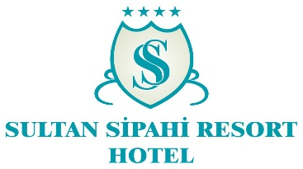***ALL-INCLUSIVE OFFER 2024***

**MEALS**

|  |  |  |
| --- | --- | --- |
| * Breakfast buffet | Hotel restaurant | 07:30 – 09:30 |
| * Late breakfast buffet | Hotel restaurant | 09:30– 10:00 |
| * Lunch buffet | Hotel restaurant | 12:30 – 14:00 |
| * Snacks | Snack Bar (at swimming pool No. 2) | 11:00 – 16:00 |
| * Afternoon tea | ground floor restaurant, Building B | 16:00 – 17:00 |
| * Dinner buffet | Hotel restaurant | 19:00 – 21:00 |
| * Night Owls’ soup☺ | Hotel restaurant | 23:00 – 00:00 |
| *Drop by the Snack Bar (at swimming pool No. 2) during breakfast, lunch and dinner to enjoy hot dishes prepared fresh by our chefs.* | | |

**BEVERAGES**

|  |  |  |
| --- | --- | --- |
| * Swimming pool bar | Local spirits and soft drinks | 10:00 – 23:00 |
| * Beach bar | Local spirits and soft drinks | 10:00 – 18:00 |
|  | Paid bar with beverages not part of the All-Inclusive package | |
| * Freshly squeezed juice – paid, not part of the All-Inclusive package | | |
| * Minibar – water, replenished daily | | |

**FOR USE BY HOTEL GUESTS**

*.*

* hammam, fitness
* swimming pool
* sauna
* table tennis, darts
* baby cot
* deck chairs, mattresses and sun umbrellas in the swimming pool area
* swimming pool bar: beer, gin, vodka, wine
* mini-club for children aged 4-12: 10:00 until 12:00 and 14:00 until 17:00
* hotel Wi-Fi in general access areas

**PAID SERVICES**

* imported spirits (whisky, long drinks, liqueurs)
* deck chairs, mattresses and sun umbrellas on the beach
* freshly-squeezed juice
* water pipe
* hairdresser

**HOTEL RULES**

* No access in wet clothes or swimwear to the restaurant area during breakfast, lunch, and dinner.
* No animal admission to the hotel.
* Housekeeping: 09:00 – 16:00
* Check-in time: 14:00 , check-out time: 12:00 p.m. (late hotel room key return carries an extra charge at the reception).
* Turkish coffee
* massage, spa & wellness
* use of telephone and fax
* laundry
* water sports
* physician’s assistance
* hotel safe
* late check-out
* Wi-Fi in hotel rooms
* currency exchange