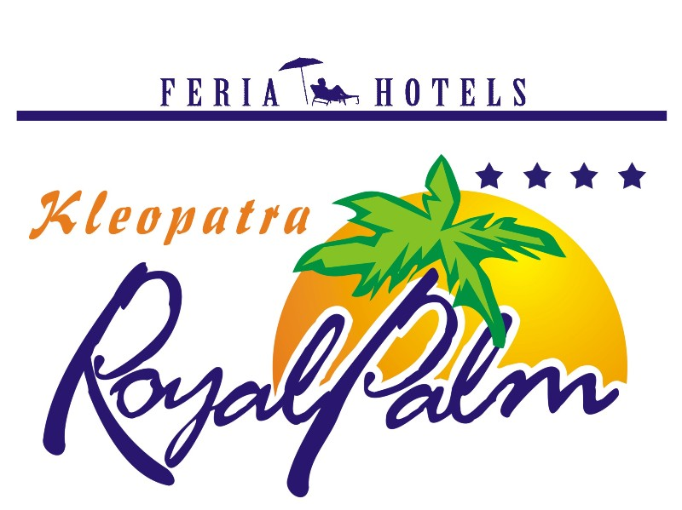
KLEOPATRA ROYAL PALM HOTEL
2023 ALL INCLUSIVE CONCEPT

Breakfast 08:00-10:00
Snack at Pool 10:00-12:30 & 14:00-17:00
Lunch 12:30-14:00
Coffee and cake 17:00-18:00
Dinner 19:00-21:00
Pool bar; local drinks 10:00-23:00
* The time can be changed in the season
* It‘s not allowed to serve alcohol drinks under 18 years old guests.

Free of Charge Services (Included on All Inc.)
TV (Sat)
Table Tennis
Dart
Garden & Beach Volleyball
Turkish Bath
Fitness room
Pool sun bed and umbrella
Children Park

Services with an Extra Charge
All import drinks (including Miller and Beck’s beer)
Minibar-Room Services
Telephone and Fax
Safe box in the room
Sauna
Massage
Peeling
Watersport
Doctor
All kind of Ice-cream, waffles, all cakes outside the buffet
All fresh juices
Billiard
Internet corner
Sun bed and umbrella on the beach
A la carte lunch & dinner which are served at the snack bar or beach
Turkish coffee
Wi-Fi

