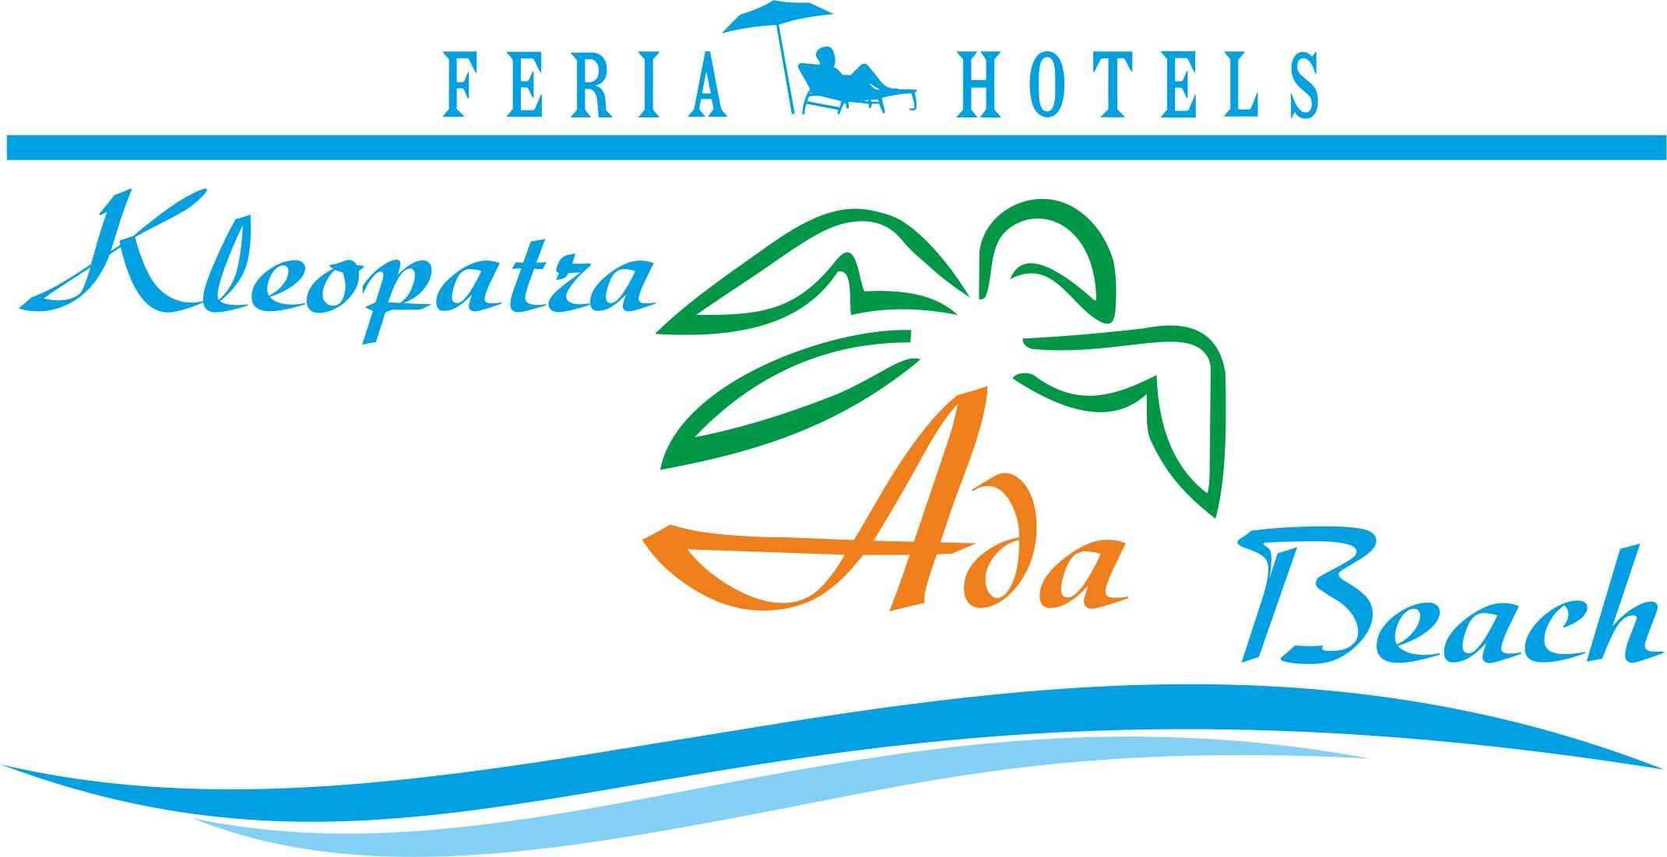 KLEOPATRA ADA BEACH HOTEL **** ALANYA – ANTALYA, TURKEY

MORE INFORMATION

Check-in Time | 14:00
Check-out Time | 12:00
Number Of Floors | 5
Number Of Rooms | 86
Year Of Construction | 1993
Last Renovation | 2013
Address | Saray mah. Ataturk cad. Alanya – Antalya
Tel | 0 242 513 78 44
Fax | 0 242 513 29 67
E-mail | sales@feriahotels.com
Web Site | www.feriahotels.com

CONTACTS

Title | Mr.
First Name | Ali Kayhan
Last Name | Demir
Position | Sales & Marketing Manager
Phone | 0 242 513 78 44
Fax | 0 242 513 29 67
E-mail | sales@feriahotels.com
Address | Saray Mah. Atatürk Cad. Alanya – Antalya
City | Antalya
Zip code | 07400
Country | Turkey

GENERAL HOTEL INFORMATION

Kleopatra Ada Beach Hotel is located in Kleopatra beach; it takes 1 km to Alanya center, 10 m to the beach, 118 km to Antalya Airport.
Taxi and minibus are available for your transportation.
The hotel has 86 rooms including 200 beds totally.

Address: Saray Mah.Ataturk cad. Alanya – Antalya / Turkey

ROOMS

Standard Rooms
Rooms are about 22 m2 and ceramic flooring. They have a bedroom including split air condition, satellite TV, music channel, safe box (with extra charge), telephone, mini bar (with extra charge), a bathroom including shower, WC and hair dryer, a balcony. They have minimum 2 pax and maximum 3capacities. Room service is also available between 08:00 -24:00

AMENITIES

Features (free of charge)

Outdoor Swimming Pool

Outdoor Kids’ Pool
Baby cot
Kids’ Playground
Sun beds (by the pool)
Sun umbrellas (by the pool)
Mattress (by the pool)
Sea (sandy)
Beach (sandy)
Breakfast, lunch and dinner
Elevator

TV Hall

Sports & Activities
Internet (with extra charge)
Billiards (with extra charge)
Sauna, massage, beauty centre (all with extra charge),
Water Sports (all with extra charge),
Turkish bath (entrance, free of charge)
Dart (free of charge)
Table tennis (free of charge)
Beach volley (free of charge)
Fitness room (free of charge)
Animations and shows (two times in a week, free of charge)

BARS & SNACKS

Pool Bar
Service hours are between 10:00 and 00:00.
(All inclusive: 10:00-23:00 o’clock)
It’s not allowed to serve alcohol drinks under 18 years old guests.

Beach Bar
Service hours are between 08:00 and 17:00.

DINING

Restaurant
The restaurant has 120 pax, and 180 pax outdoor capacities.

Breakfast 08:00 – 10:00 (buffet)
Snack 10:00 – 12:30 & 14:00 – 17:00 (pool)
Lunch 12:30 – 14:00 (buffet)
Coffee and cake 17:00 – 18:00 (buffet)
Dinner 19:00 – 21:00 (open buffet)

GOOD TO KNOW

Not included in the Package (all with an extra charge)
Doctor
Mini bar – room services
Safe box
Sun beds (on the beach)
Sun umbrellas (on the beach)
Mattress (on the beach)
Laundry
Telephone and fax
All fresh juices
Espresso, cappuccino and Turkish coffee
All import drinks (including Miller & Backs beer)
All kind of ice-cream
Internet

