If you are an air traveler who thinks airport formalities are a hassle, here is the perfect way to avoid it.

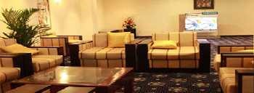

**Package Includes**

Silk Route Arrival Lounge

**Opening Hours**

24 hours daily.

# Facilities

**Silk Route Arrival Lounge:**

* Receiving the guest as he disembarks and accompanying him to the Silk Route Lounge by Airport staff
* Baggage collection and delivery by Airport staff
* Internet, WiFi, Audio Visual Entertainment • Dedicated exit passage way and parking

# Conditions

* All Passengers can stay in the Arrival/ Departure Lounge, until the Arrival/ Departure formalities are completed
* Children under 02 years are admitted free

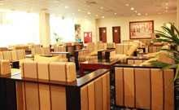

Silk Route Arrival Lounge