If you are an air traveler who thinks airport formalities are a hassle, here is the perfect way to avoid it

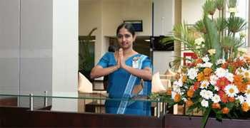

**Welcome to the Silk Route Lounge**

**Package Includes** Silk Route Arrival Lounge

Silk Route Departure Lounge

Executive Lounge

**Opening Hours** 24 hours daily.

# Facilities

**Silk Route Arrival Lounge:**

* Airport staff receiving the guest as he/she disembarks and accompanying the guest to the Silk Route Lounge
* Baggage collection and delivery by Airport staff
* Internet, WiFi, Audio Visual Entertainment
* Guest can enjoy refreshments while Airport staff collects the baggage
* 02 Visitors are permitted inside the Lounge to welcome their guest
* Airport staff receiving the guest at the entrance to the 'Silk Route' Lounge
* Dedicated exit passage way and parking

**Silk Route Departure Lounge:**

* Receiving the guest by Airport staff at the entrance to the 'Silk Route' Lounge
* Baggage will be screened inside the lounge by the Airport staff
* Check-in procedures will be attended to by either the Airport Staff/ SriLankan Airlines Staff while the Guest relaxes in the 'Silk Route' Lounge.
* After completion of formalities, the guest will be escorted to the Transit/Boarding Area through a dedicated passage. Airport Staff will be with the guest right through his journey across the Departure Terminal
* Visitors are not allowed to the Departure Silk Route Lounge
* No meals/ refreshments are provided at the Departure Silk Route Lounge

**Executive Lounge:**

* Internet
* Telephone (Local Calls) • Pleasant Environment

# Conditions

* Guest should report to the Departure Silk Route Lounge before closing the Check-in Counters
* All Passengers can stay in the Arrival/ Departure Lounge, until the Arrival/ Departure formalities are completed
* Children under 02 years are admitted free

•

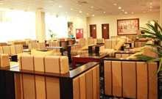

Silk Route Arrival Lounge

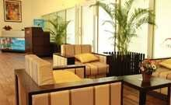

Silk Route Departure Lounge

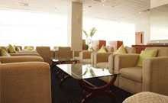

Executive Lounge