## **Gold Route Lounge**

### Discover Our Services

**The premium fast track service for Arrival and Departure at BIA**

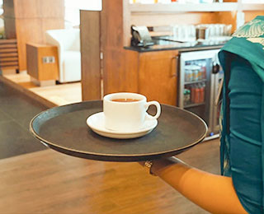

#### **Lavish Hospitality**

We can make traveling easier and more convenient providing you with a lavish hospitable experience on your airport journey.

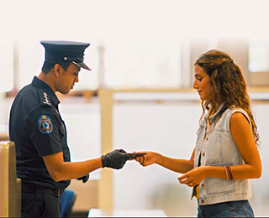

#### **Speedy Clearance**

You will have the luxury of having expedited process at the airport including check –in, passport control and customs formalities fulfilled at the lounge itself.

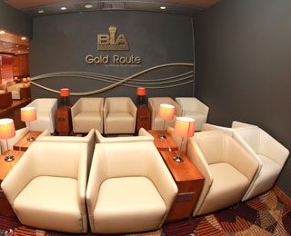

#### **Exclusive Lounge Facility**

You can relax until your airline is preparing to start boarding at our cozy **Gold Route Lounge**.

## Our Services

### Would you like to move your airport experience to the next level?

Now, you can enjoy the premier airport service experience on your arrival and departure with our newly introduced Gold Route Service at Bandaranaike International Airport.

The Gold Route service offers you highly privileged and prioritized services, including an exclusive lounge facility, dedicated staff to take over the entire check-in process, passport control, and luggage check-in. You can relax and make use of our amenities to the fullest. You can enjoy the refreshments and relax during your waiting time with free WIFI

The exclusive Gold Route Service will provide you the access to your private vehicle at the entrance of the Gold Route Lounge.

Our new Gold Route service will make your airport experience pleasant as never before. Start your reservation to enjoy the premier airport experience.

### The Premium Airport Experience

##### **Bypass the normal passenger path**

You will be personally greeted and attended by our Gold Route staff. Bypassing the normal passenger path, you can relax in total privacy in the Gold Route lounge, where security, customs, check-in, and immigration/emigration formalities are taken care of.

##### **Stay in the Gold Route Lounge**

Gold Route Lounge is here to offer you more privacy, space, and comfort. You can enjoy a variety of refreshments & beverages while you unwind before/after your flight.

##### **Internet and Wi-Fi**

Do you need to attend to some urgent work while you're on the move? We provide you with uninterrupted Wi-Fi service at our Gold Route Lounge.

## Airport Gold Route Services

### Airport Gold Route Services in Sri Lanka

###### [Arrival Gold Route Services](https://www.airport.lk/gold-route/index)

* Passengers are escorted to the Gold Route Lounge from the aircraft.
* Customs and immigration formalities are done inside the Gold Route Lounge.
* Refreshments and beverages will be made available.
* Baggages are collected by dedicated staff.
* A maximum of three visitors will be permitted inside the lounge per passenger movement.
* Vehicles are permitted in the VIP lounge vehicle parking area.
* Exit through a dedicated path after clearing the formalities.

##### **Note: Arrival reservations can be done 03 hrs before the arrival flight time**

###### [Departure Gold Route Services](https://www.airport.lk/gold-route/index)

* Dedicated vehicle parking area at the VIP premises.
* Ensure all security formalities are met by AASL.
* The passenger is escorted by AASL staff to the Gold Route Lounge.
* All required departure formalities (customs, check-in, and emigration) are done inside the Gold Route Lounge.
* Baggages are handled by dedicated staff.
* Refreshments and beverages will be made available.
* A maximum of three visitors will be permitted inside the lounge per passenger movement.
* Personalized service for boarding.
* Currency exchange is facilitated with a security escort to the departure bank area.
* Wheelchair facilities will be provided for passengers.

##### **Note: Departure reservations can be done 06 hrs before the departure flight time**